Practical advice for GP practice teams when community pharmacy EPS or IT systems fail for an extended time

- General information and business continuity planning:
When community pharmacies suffer an IT failure and EPS system goes down for an extended time i.e., more than 24 hours, they should have mitigations put in place as part of their business continuity plans, including contacting affected GP practices. Further information is available on PSNC website IT and EPS contingency planning - PSNC Website.
The PSNC recommends that pharmacies discuss relevant aspects of their plans with local GP practices. If practices do not currently have access to this information, they may wish to contact their local pharmacies to discuss. At the time of writing, the LPC has written to all local pharmacies to encourage them to contact practices if they have not already done so.
PSNC have very useful guidance on how GPs and pharmacies can work together on EPS business continuity :PSNC-Briefing-076.16-How-GPs-and-pharmacies-can-work-together-on-EPS-business-continuity-002.pdf

- Mitigations GP practices could consider when there is a community pharmacy closure /IT failure and EPS is unavailable:

- Ensure practice staff know how to use the EPS Tracker to track and cancel prescriptions. For EMIS users see EMIS Web EPS guides (available through EMIS Now – see later)

- Use EPS Tracker and using the GP practice site code, list EPS prescriptions in a set date range and filter by their status to determine their whereabouts.

- Prescriptions not downloaded by the pharmacy will remain on spine, so giving the patient the barcode (via token) or using their NHS number (on NHS App) will enable them to collect from elsewhere. See also under d) how patient can collect their prescription without attending the practice.

- Consider pre-empting patient queries by sending bulk Accurx messages to those patients affected, for example advising only contacting the practice if urgently going to run out of medication.

- It is possible to search on EMIS for EPS prescriptions issued to the nominated pharmacy within a certain date range – this may help practices to identify which prescriptions to check on EPS tracker. Criteria – all drugs (rule 1 - medication issues with date range), specific pharmacy (rule 2 from patient details)

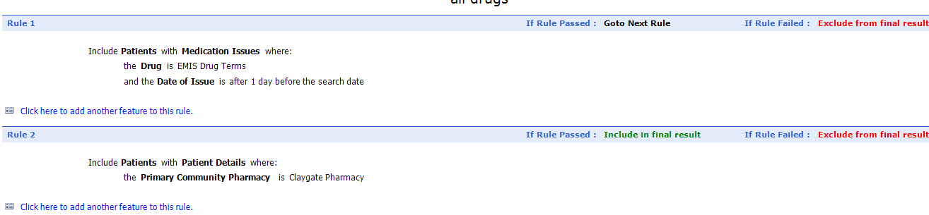

- For acute prescriptions, consider sending patient prescription token remotely.

- Ensure patient does not have nominated pharmacy for this issue, it is possible for the patient to collect their prescription without coming to the practice for their printed token by providing their NHS number or token ID to the pharmacy. Information on how to provide this to the patient is here: EMIS Web - EPS hints and tips (emisnow.com) (How the patient can collect prescription without a token)

- Reversion to paper FP10s

How to use EMIS Now (www.emisnow.com):

EMIS Now is a support website with training guides, videos, help and news for all EMIS products. You can access the EMIS Now website if you register using your organisation ID/CDB number.

